**LCM** **OF TWO NUMBERS**

**Expt:no:11**

**AIM**: To find the LCM of two numbers using 8085 processor.

**ALGORITHM:**

**1.** Set DE as the 2's complement of BC register.

2. This DE is used to subtract BC from HL pair.

3. The method is like this: let us say the numbers are 2 and 15.

4. When we divide the first number by second, and then if there is no remainder, then the first number is the LCM.

**INPUT**:

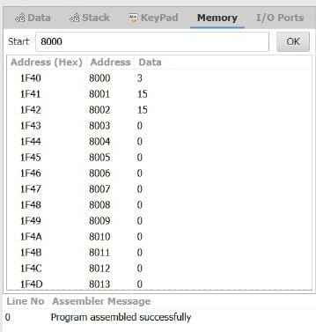

OUTPUT:

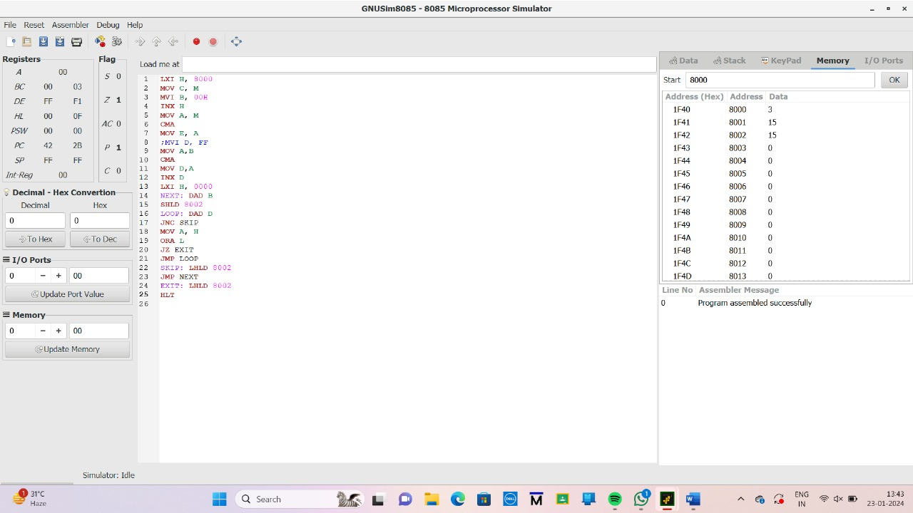

**RESULT**: Thus the program was successfully implemented using 8085 processor